What to do with Glen Canyon Dam? – An Engineer’s Perspective
By John Vrymoed PE, GE
President, Grand Canyon Private Boaters’ Association
December 29, 2023

Introduction

This paper examines the design of Glen Canyon Dam (GCD), modifications under consideration by US Bureau of Reclamation and recommends alternative modifications. The latter are aimed at mitigating the negative effects that the dam’s construction and operation have on the health of the river corridor’s ecosystem (RCE). The dam has now been in operation for 57 years and its operation has slowly degraded the river's ecosystem. Without any modification and change in operation, this degradation will continue.

The degradation is due to a number of factors: 1. The daily fluctuation of flows eroding the beaches so that the monetary value of hydro power is maximized; 2. The elimination of sediment transport downstream; 3. Water temperature releases unfavorable to the aquatic environment, and 4. Inability to release historic high flows given less than full reservoir levels. Additionally, releases to meet downstream demands are not possible should the reservoir level fall below the river outlet works (ROW).

Diversion of River Flows During Construction

It is assumed that the reader is familiar with the location, history and purpose of GCD and has an interest in the RCE. As such, this information will not be summarized here since it is readily available on the internet. So, let’s jump into the discussion.

An aerial plan view of GCD, diversion tunnels, spillway intakes, river outlet works (ROW) and turbine intakes are shown in Fig.1. These are key features, which will be referred to throughout this discussion starting with a brief history of the river’s diversion.

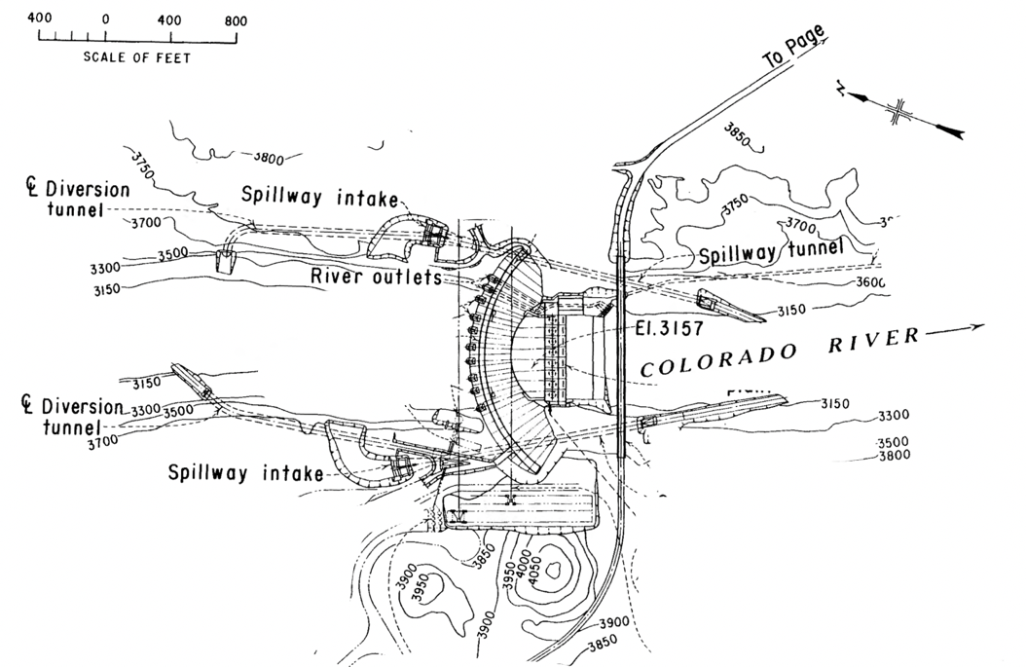
The diversion tunnels channeled the river around and past the construction site. The tunnels were designed to pass a 1:25 year flood event of 125,000 cubic feet per second (cfs).
Figure 1 Aerial view

The right tunnel’s intake was at the river’s level and diverted flows once the river channel was blocked. Looking upstream, the photograph in Fig 2, shows flows exiting the tunnel. The photograph in Fig 3 is provided to give a sense of the tunnel’s size. Figure 4 shows the right tunnel flowing half full with steel plates in place in anticipation of its closure.

The left tunnel intake was constructed 30 feet higher in elevation than the right. This allowed construction of the control gates inside the tunnel to divert flows once the right tunnel was closed. The left tunnel remained in operation to meet downstream demands while construction continued and the reservoir continued filling. Once the reservoir reached the ROW, the tunnel was closed and abandoned. The ROW’s 15,000 cfs capacity was satisfactory to meet downstream demands and were closed once the reservoir reached the turbine intakes. It was the intention to only use the ROW to release storm inflows in conjunction with spillway releases. They are now used for High Flow Experiment (HFE) releases.
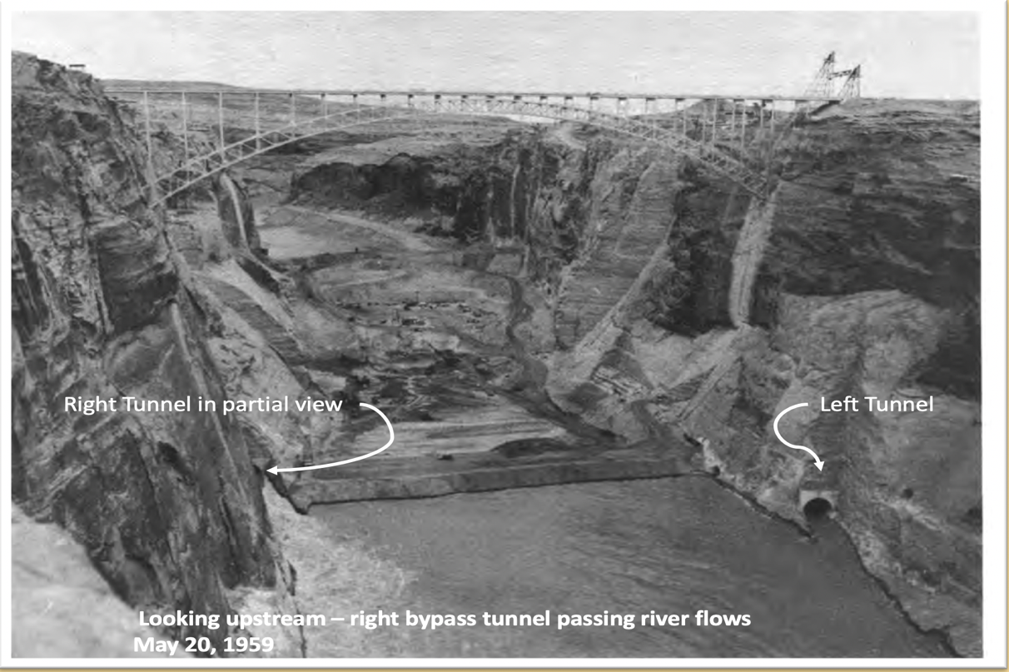
Figure 2 Looking Upstream

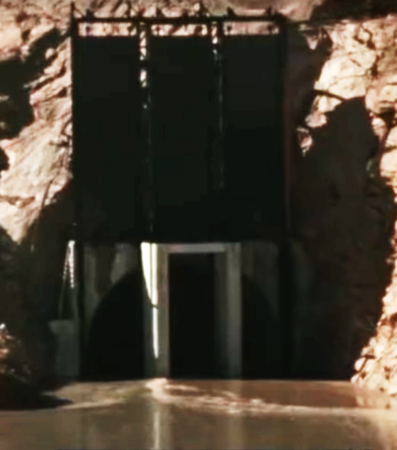
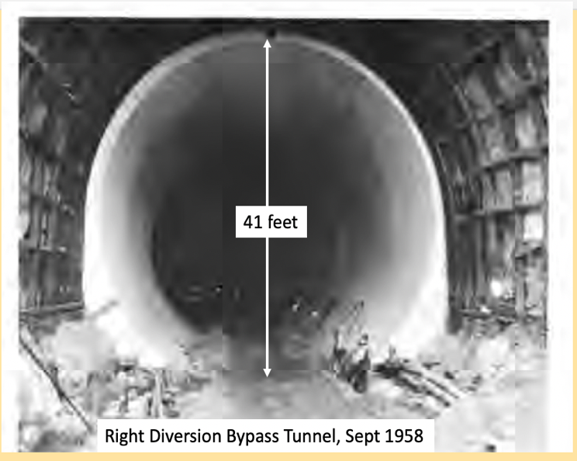
Figure 3 Right Diversion Tunnel with Steel Gates flowing half full
pa
p
Figure 4 Scale of Right Diversion Tunnel

Glen Canyon Dam’s Limited Operability

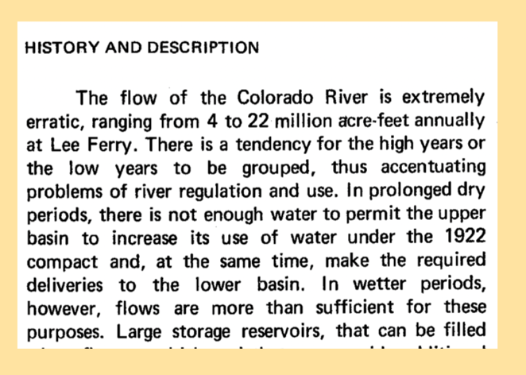
The decision to close and abandon the bypass tunnels basically resulted in a reservoir without a drain at the bottom. This shortened the lifespan of the dam by trapping sediment and prohibiting the replenishment of beaches downstream. Additionally, the left tunnel’s capacity could have been utilized to reduce storm inflows as occurred during the 1983-84 runoff, which peaked at 125,000 cfs. It also prohibited access to the 1.75 million acre feet below the ROW’s elevation which is referred to as “dead pool.” Perhaps the most negative aspect of this decision is that downstream demands could not be met should the reservoir fall below the ROW. The extreme variation of flows and the corresponding possibility of a prolonged drought was recognized as indicated in the text from the Technical Record of Design and Construction, see Figure 5.
Figure 5 Text, Record of Design and Construction

The dam’s operability is further limited by the turbine intakes positioned at the same elevation, shown in Figure 6. Staggering some of the intakes at different elevations would have allowed for warmer releases from the higher elevations and from the lower elevations to meet downstream demands should the reservoir level fall below the ROW.

To emphasize the design’s lack of foresight, it is instructive to consider the abandonment of the left tunnel bypass and its gate control structure, as their construction constituted a significant and costly undertaking.

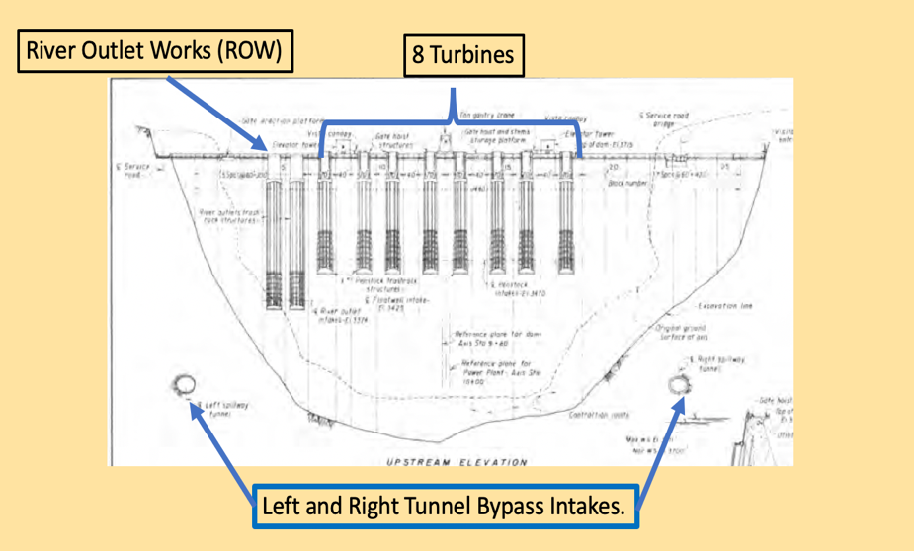
Figure 6 Upstream Face GCD

Permanent Use of the Left Diversion Tunnel Foregone

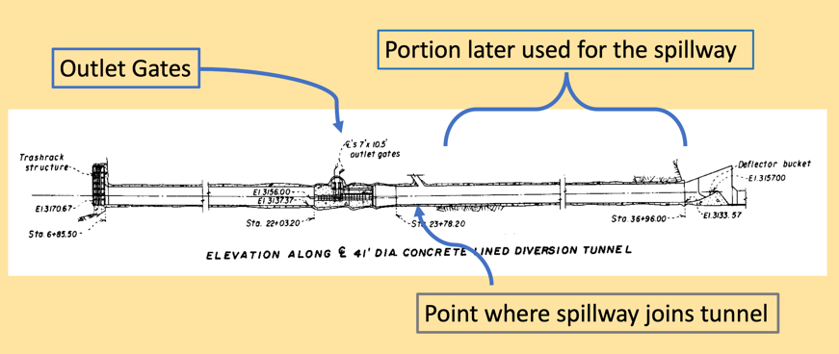
An elevation view of the left tunnel is shown in Fig 7. The tunnel is 41 feet in diameter, concrete lined and 3000 feet long having a capacity of 32,000 cfs. This capacity is equivalent to the combined capacity of all 8 turbines. The flow was controlled by 6 outlet gates. The gates were 7 by 10^{1/2} feet and controlled hydraulically. They were designed to withstand a head of 561 feet or full reservoir level.
Figure 7 Elevation View, Left Bypass Tunnel
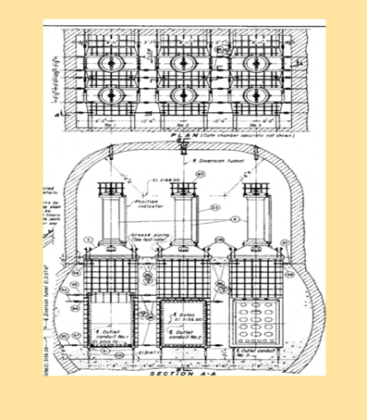
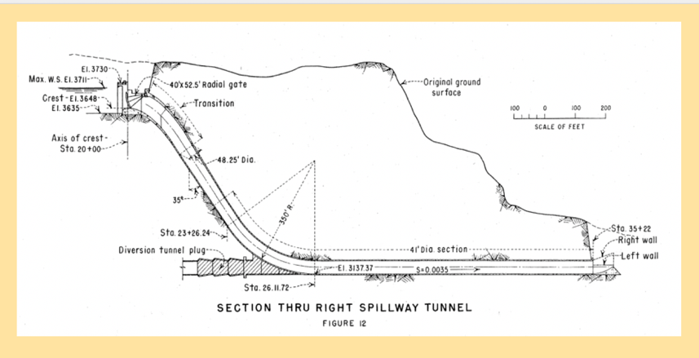
Figure 8 Cross Section, Control Gates
Figure 9 Spillway/Bypass Tunnel Intersection

Thus, the tunnel could have served the life of the dam providing numerous benefits to its operability and served to benefit the RCE. It was not to be. The tunnel was blocked at the spillway’s intersection by the placement of concrete in a 150-foot long section as shown in Fig. 9. This required 22,000 cubic yards of concrete, which had to be refrigerated during placement to keep the temperatures within limits - at a cost of $6.8 million in today’s dollars. The gate operating chamber, conduits, shown in Fig 8, as well as the access adit were similarly “filled with backfill concrete and grouted after the outlets had served their purpose.”

Coulda’ Woulda’ Shoulda’

The left diversion tunnel should never have been abandoned. In addition to the previously mentioned benefits, leaving the tunnel in place would have increased the maximum outflow to 77,000 cfs, equivalent to a 1:3 year flood event - sans spillway releases. It is well recognized that the health of the RCE benefits from periodic flooding. Prior to the dam’s construction, a peak flow of 45,000 cfs had a 100 percent probability of occurrence – lasting 2 weeks or more. By way of an HFE, this flow now only occurs once every 3 or 4 years – limited to 3 to 4 days.

One can only assume that the tunnels were abandoned for two reasons: 1) Cost savings by using one half of the tunnel’s lengths for the spillways, and 2) The tunnels would not be utilized to generate hydropower, and therefore “was determined to serve no useful purpose”

Rule Curve

A rule curve governs the allowable reservoir level for specified months of the year in order to adequately contain runoff. In the case of GCD, funding for flood control purposes, as part of the dam’s overall construction cost, was not provided. As such, the adequacy to contain runoff is based on hydrologic models of the Upper Basin, in combination with weather forecasts.

The goal is to fill the reservoir to the top of spillway gates, see Fig 9 and use the 45,000 cfs outlet capacity to control reservoir levels without raising the gates. All to maximize hydropower. Enter 1983/1984. With a full reservoir, an unexpected high runoff necessitated raising the gates. Flows, having velocities of 160–190 ft/sec, caused major damage to the spillway tunnel, tearing out the concrete lining and eroding a 40-feet deep hole in the underlying sandstone. The spillway failure at Oroville Dam, California in Feb 2017, shows that these types of failures do occur - despite inspections by multiple agencies.

Spillways and their gates may not be used for long periods of time – will they function properly when needed? These failures demonstrate the criticality of having an adequate outlet capacity in conjunction with operation of the gates. It is a safety concern and not a “nice to have.” Again, GCD’s spillway incident underscores the impact and consequence of abandoning the river bypass tunnel, thereby limiting its outflow capacity.

Reclamation’s Modifications

Appraisal studies of various alternatives for modifying the dam were initiated by Reclamation due to the possibility of the reservoir’s level dropping below the turbine intakes. The alternatives, presented in a power point presentation, consist of lowering the existing intakes, shown in Fig 10, adding a power plant to the ROW, and power plants connected to intakes at the left and right abutments. These intakes would be located at the same elevation as the ROW.

Flow and Megawatt (MW) totals for each alternative are summarized in the table below. Reclamation’s presentation did not include details on the size of penstocks, gate controls, limiting velocities and how construction challenges would be met since the intakes are below the minimum power pool. Would the reservoir be lowered to just above the ROW and halt power production to facilitate construction?

As part of these alternatives, Reclamation is also investigating augmenting hydropower with solar and wind energy. The neighboring Navajo Nation has successfully completed Kayenta I and II solar arrays generating 55MW on 365 acres.
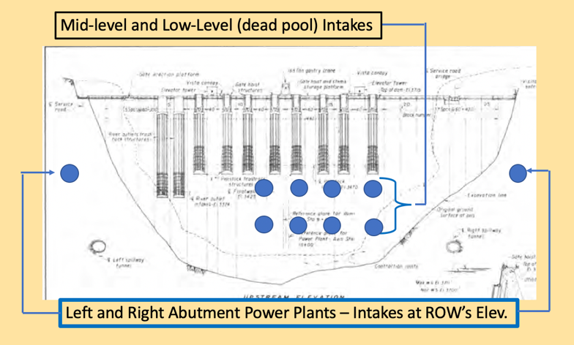
The technical potential for solar energy on tribal lands have been studied and found the Navajo to have the greatest potential of all the tribes. The study cites a potential of 902,154 MW (7400 times greater than GCD’s capacity).
Figure 10 Locations of Reclamation's Intakes

The necessary footprint for solar energy has been conservatively found to require 10 acres to produce 1 MW. This is significantly greater than Kayenta’s footprint of 6.6 acres per 1 MW. The Nation is comprised of 16 million acres. Given the scale of these numbers, it is worthy to explore the option of partnering with the Navajo Nation/Navajo Tribal Utility Association.
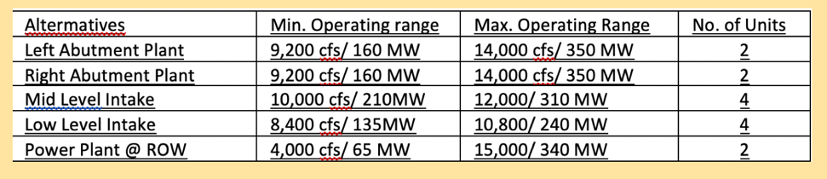
By initiating these studies, Reclamation has now recognized the extent of the dam’s limited operability. The alternatives, however, do not provide any benefit to the RCE.

Review of Reclamation’s Alternatives

Construction of Reclamation’s mid and low-level intake alternatives present significant challenges. The mid-level intake would require blasting/drilling/excavating a 14-foot-diameter tunnel through 5,000 – 6,000 psi concrete having 1½ to 6 inch sized aggregate. It would further require extending the gate system and abandoning the existing intake by backfilling with concrete.

The low level intake schematic in Figure 11 would require drilling thru the entire base of the dam to connect to the existing penstocks – while under +200 feet of water. These two alternatives do not add hydropower – they simply allow for lower intakes over what exists currently.

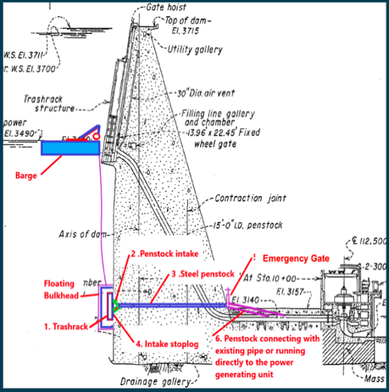
Construction of a power plant connected to the ROW similarly presents challenges. The ROW allow releases downstream should the reservoir level fall below the turbine intakes. There is a risk of not being able to meet the downstream demand during the years needed for the plant’s construction. Is this a risk worth taking?
Figure 11 Low Level Intake Alternative

The left and right abutment plant alternatives provide a greater benefit by adding hydropower and pose less of a risk by not tunneling thru the dam and halting operations - and not interfere with the ROW’s functionality.

Reclamation dismissed an alternative of adding a power plant to the right by-pass tunnel because of sediment potentially damaging the turbine’s wicket gates and runners. This alternative should be further evaluated.

Sediment management strategies have been considered for many dams including redesigning infrastructure with abrasion-resistant materials. The sediments are probably eroded Navajo Sandstone, which is comprised of mainly quartz with minor amounts of feldspar. It would be worthwhile to test their hardness, or Mohs value, to assess whether scouring presents a significant problem.

A Better Alternative Modification – Adding an Inlet Tower

Most dams and reservoirs have one or more inlet/outlet towers. GCD does not. The lack of a tower and GCD’s design are primary factors limiting its operability. Because they are a common feature in the design of dams/reservoirs, the Army Corps Engineers provides guidance for their use and design. Similarly, the industry has stressed the need for an inlet tower for safety and operability. Why a tower was not deemed necessary is not mentioned in Reclamation’s Technical Record.

The concept of an inlet tower along with an example of USACE’s design for a sloping tower are shown in Figures 12.
The design of intake towers varies greatly depending on their purpose and need. The controls for operating the inlets are located at the tower’s top. For vertical towers, access is typically done via a bridge to the shore or dam itself.
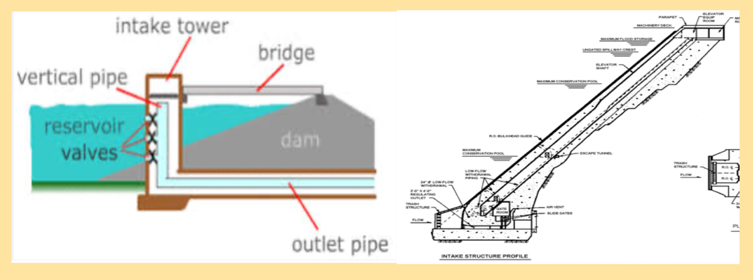
Figure 12 Schematic of Intake Towers and Design of Sloping Intake Towers

Images showing a variety of types of towers are shown in Fig 13. An inclined versus a vertical tower has the benefit of not requiring a bridge for access. The tower example on the right of Figure 8 is probably the most suitable for either side of the canyon.

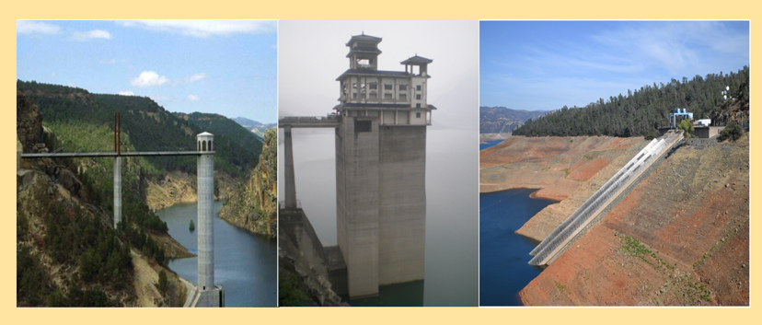
Figure 13 Examples of Inlet/Outlet Towers

Potential Inlet Tower Locations
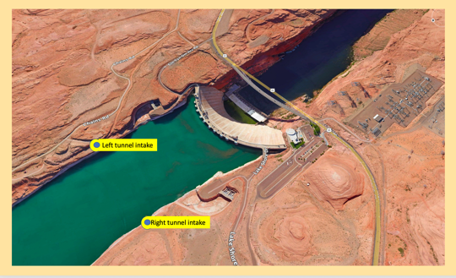
Figure 14 Potential Inlet Tower Locations
Potential tower locations are above the right and left by-pass tunnel intakes, as shown in Figure 14. The locations are upstream of the spillways and provide ample access for equipment and a construction yard.

The competency of the Navajo Sandstone would lend itself to excavating the weathered portion to reach a suitable foundation for an inclined intake tower. There is an abundance of geotechnical data available on the sandstone from previous investigations. The difficulties experienced during tunneling thru the sandstone by way of slabbing is well known and documented. What is not known is the extent of seepage from the reservoir thru the sandstone’s joints, which can be determined by subsurface exploration.

Inlet Tower Intakes - Upper Level Intake at Elev. 3550

Lake Powell temperatures are stratified as shown in Figure 15. An upper level intake at Elev. 3550 (150 feet below full spool) would allow the release of warmer water to benefit the aquatic ecosystem.

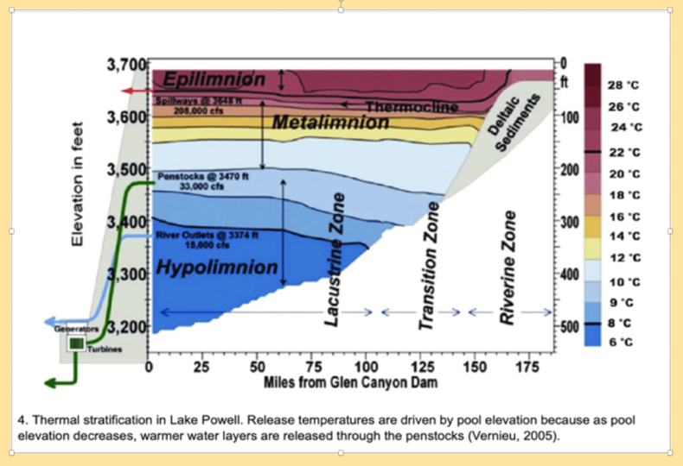
Prior to the dam, Colorado River temperatures were much warmer in the summer and fall than releases from the turbines. At Elev. 3550, temperatures vary from 72⁰ F to 82⁰ F at full pool. These are in contrast to the temperatures of 50⁰ F and 43⁰ F for releases from the penstock and ROW elevations, respectively.
Figure 15 Lake Powell Thermal Stratification

Sizing of the intake would consider mixing the amount of warm with the colder water released thru the turbines. For example, the releases can be varied to provide the maximum benefit for the humpback chub during spawning season to meet the ideal temperatures of 59⁰ to 68⁰ F.

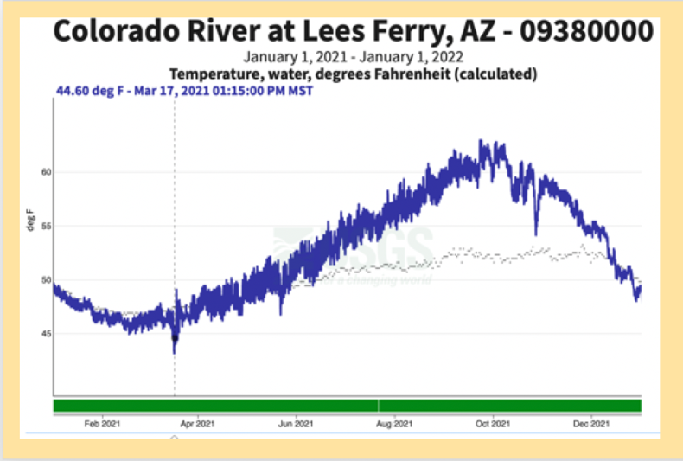
The timing of releases can take into consideration the yearly variation of temperatures. The variation in Fig 16 is for calendar year 2021. A low of 45⁰ occurred on March 17, and a high of 63⁰ on Sept 22. The reservoir elevation for that year started out at Elev. 3580 and dropped steadily to Elev. 3540. So, in the Fall of 2021, the proposed upper level intake could no longer release water but the warmer water would then be solely provided thru the turbines.
Figure 16 Variation of Temperatures for 2021

Upper Intake at Elev 3550 to Generate Hydro Power

An upper level intake, in addition to releasing higher temperature waters, could also be used to generate hydro power. Hydro power could be generated for a vast majority of the reservoir’s history given historic elevations shown in Fig. 17 – these elevations are well above the intake’s elevation.

It is beyond the scope of this discussion to analyze all the variables that go into a turbine’s design. However, given the same design of the existing turbines, a maximum capacity of 143 MW is approximated. This value is less than the existing turbines, rated at 168 MW, due to the much greater length of the penstock. A cost benefit analysis can determine the optimal generating capacity considering the many variables that go into turbine and power plant design.
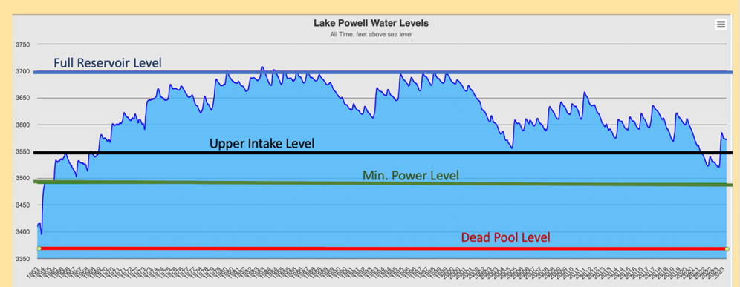
Figure 17 Historic Reservoir Levels

Middle and Lower Level Intakes

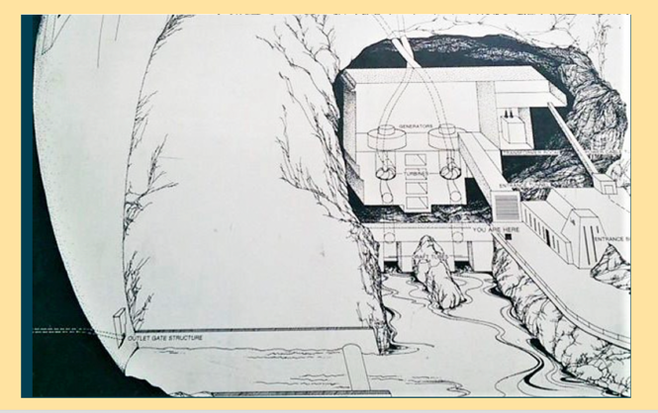
Figure 18 Reclamation’s Artist Rendering of Power Plant
Similar to Reclamation’s alternatives, tower intakes at mid and/or low level Elevations of 3425 and 3285, would allow releases from below the ROW and be able to provide hydropower. As opposed to Reclamation’s alternatives, these alternatives add to and not substitute the existing capacity.

Where to place a power plant below the dam presents challenges because the existing infrastructure is crowded into the narrow canyon. Additionally, an area is needed to accommodate the releases from the spillways and ROW.

The artist’s rendering of a power plant in Fig 18, taken from Reclamation’s left abutment alternative, would be ideal. An option would be to locate the plant further downstream and thereby lengthen the penstocks. A cost benefit analysis would compare the cost of excavating a chamber versus moving the plant downstream.

Access to the River/Reservoir Upstream of the Dam

For the long term benefit of the RCE, any modification would require access to the reservoir upstream of the dam to allow the transport of sediment. An assessment is necessary whether to place an intake at or just above the current silt level. The depth of sediment would need to be confirmed by bathymetric surveys. Depths of 30 to 40 feet above the abandoned tunnels have been assumed.

An inlet tower could serve this purpose or a modification of the right by-pass tunnel. For the latter, gate control structures to control flows plus their access would be required like the ones abandoned in the left bypass tunnel. As such, consideration should be given to potentially utilizing the existing or part of the abandoned by-pass tunnels. Is “abandoned” the appropriate term or is “destroyed” more appropriate? An assessment would have to be made if this infrastructure could be salvaged as part of any modification.

The sediment’s toxicity would also have to be determined. A high level of a sediment’s toxicity have posed serious challenges when decommissioning obsolete dams. A river provides a cleansing process whereby pollutants are flushed down stream. A dam simply collects these pollutants and stores them in the sediments. Information on the sediment’s toxicity is unavailable. What is known is that the Gold King Mine spill in 2015 on Cement Creek washed downstream though Durango to the San Juan River and eventually to the upper reaches of Lake Powell.

From the Intakes to the Plant

Penstocks convey flow from an intake to the power plant. They are ideally short in length to lessen the losses due to friction. For an inlet tower and/or a tunnel, the required lengths of penstocks are approximately 3000 ft to connect to a powerplant or simply release flows. A modification of the abandoned tunnels or a new tunnel can serve to house the penstocks. The photograph in Figure 19 shows how penstocks could be accommodated inside a tunnel.
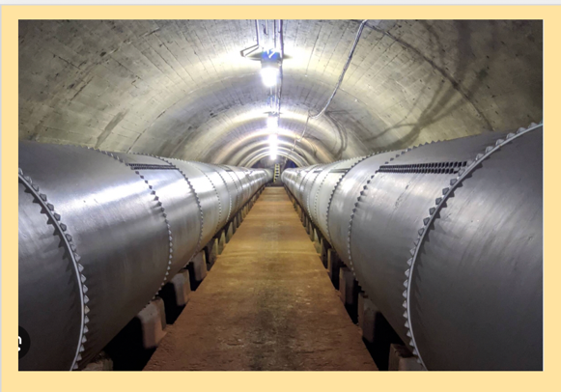
Figure 19 Penstocks housed in tunnel

Construction Challenge

Perhaps the greatest challenge is construction under a head of water. The less head of water, the lesser the challenge and associated cost. An option is to lower the reservoir to just above the ROW and still meet downstream demands. This would limit the depth of water to 200 ft to reach the tunnel intakes. Construction cost savings would be offset by the loss in revenue by not generating hydropower during certain phases of construction.

Various methods of underwater constructions, shown in Figure 20, have been extensively used in many places around the globe. To demonstrate one method of underwater construction, the photograph in Fig. 21 is provided to show a sheet pile cofferdam is employed to construct a bridge pier.

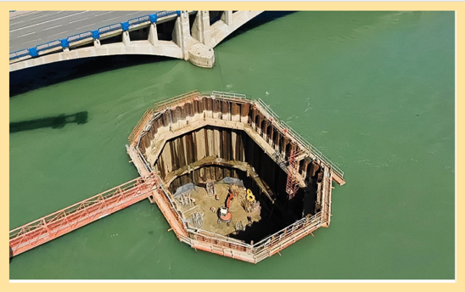
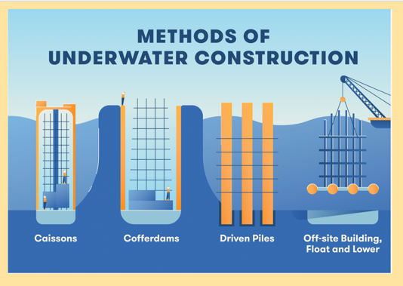
Figure 21 Sample Bridge Pier Construction
Figure 20 Methods of Underwater Construction

The construction industry is very innovative at selecting the best method for underwater construction. A good example is the method employed, just downstream from GCD, to construction a 3rd intake in Lake Mead by Southern Nevada Water Authority. This seven-year-long project consisted of a 30-foot diameter 600 deep access shaft, a 20-foot-diameter 3 mile-long access tunnel under pressures of 15 bars (500 feet of water) at a cost of $817 million.

The foregoing are conceptional level discussions. They represent a starting point for feasibility and value level analyses. The results would be the basis for a preliminary design and engineer’s cost estimate. If funded, a Request for Proposal (RFP) can be advertised in the Federal Register for the construction industry to provide methods of construction and associated costs.

The Real Challenge

Overcoming opposition by the hydropower interests will pose the biggest challenge. A brief legislative summary is provided next with a focus on how hydropower has steadily gained influence on the dam’s operation.

When legislation was enacted in 1956 to authorize the Colorado River Storage Project (CRSP), “…generation of hydroelectric power was incident to the delivery of water.” This was reiterated in 1968 in the Colorado River Basin Project Act. The marketing/selling power was transferred from the Dep’t of Interior to the Dep’t of Energy/Western Area Power Administration (WAPA) in 1977. WAPA’s mission is to sell power on the open market at the highest price, i.e. water thru the turbines = $$$.

The 1992 Grand Canyon Protection Act states that “the Secretary shall operate Glen Canyon Dam... in such a manner as to protect, mitigate adverse impacts to, and improve the values..” In 2016, Reclamation used NEPA to elevate hydropower’s influence by way of the Long Term Experimental Management Programor LTEMP. The program’s objectives were to: maintain or increase electric energy generation, meet obligations for hydroelectric power and minimize adverse impacts.

Thus, the verb mitigate in the GCPA was replaced by minimize and incident power generation was replaced with contractual obligations.
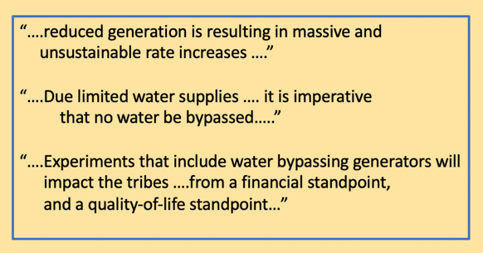
Figure 22 Comments by Hydropower Interests
Given that LTEMP degrades the intent of the GPA, it is hard to understand why the National Park Service Intermountain Region, in concert with Reclamation, asserted that: “LTEMP’s goals and objectives fully comply with the GCPA”

Hydropower interests object to “bypass” or ROW releases because it constitutes a loss of potential revenue. The Department of Energy’s Argonne National Laboratory determines the loss in revenue for every experimental release. Although canceled, a Fall 2022 HFE loss in revenue was estimated to vary between $0.56 and $6.13 million, depending on duration and time of year.

A sampling of the comments in Figure 22 by the hydropower interests, for every NEPA/EIS comment period, reflects their opposition to any bypass. Thus, the real challenge of any modification for the benefit of the RCE is the opposition by the hydropower interests. It’s all about $$$ and subsidizing their preferred customers as explained next.

How Critical is GCD’s Production of Hydropower?

This question has been evaluated and answered by others.,, The answer: It is not. “Losing electricity generation at Glen Canyon Dam would not have significant effects on the electrical grid of the Western US or on an individual consumer’s power bills.”

A comment repeatedly mentioned in favor of hydropower is GCD’s importance in providing immediate load-following capability, peaking capacity, voltage stability and control - as if Reclamation’s 57 other hydro power plants throughout the Western United States are not able to serve this need when called upon.

GCD has been referred to as a cash register – hydropower sales go toward the Basin Fund, which pays for, in part, the dam’s operation and maintenance. WAPA offers power to “preferred customers” at a cost-only basis. Preferred customers are non-profit utilities, tribes and agricultural entities. The power sold to utilities typically represents a small percentage of their portfolio.

For example, the Platte River Authority generates and delivers energy to a number of communities in Colorado. Its portfolio includes coal, wind, hydro, gas and purchases Of this mix, only 7.3% comes from WAPA contracts. Should GCD be unable to produce power, utilities that contract with WAPA can procure power on the open market instead of WAPA purchasing power at a much higher rate.

The foregoing is a thumbnail sketch of electric energy pricing. The Congressional Research Service Report²³ provides a greater detailed and unbiased description.

Section 1809 of the GCPA charges the Secretaries of Energy and Interior to identify economically and technically feasible methods of replacing any power generation that is lost through adoption of long-term operational criteria for Glen Canyon Dam, i.e. there is a remedy in place.

Lastly, it is worth noting that GCD’s generation equates to 0.3% of the Western Power Grid’s capacity of 286,000 MW. Despite the ominous drumbeat by the special interests, the lights will stay on and the sky will not fall should GCD stop producing power for any length of time.

GCMRC and GCDAMP

These acronyms stand for Grand Canyon Monitoring Research Center and Glen Canyon Dam Adaptive Management Program. A brief discussion is warranted as these entities relate to the RCE.

The GCMRC and GCDAMP are funded by GCD’s energy sales, each at about $9.5 to 10 million annually. GCMRC’s function is exactly as its title states: Monitor and conduct research. The GCMR provides scientific input to GCDAMP. The latter is composed of a large group of stakeholders who discuss protection and evaluate mitigating measures to minimize RCE’s degradation. A list of its members and respective organizations are too numerous to mention here.

GCDAMP’s budget for FY 2023 showed the humpback chub population dynamics project to receive the greatest share at $1.6 million. Second was the streamflow, water quality and sediment transport project at $1.2 million. Given the group’s size, leadership, management and support was budgeted at $1.5 million.

Extensive studies have been conducted in the past on the humpback chub and sediment transport, generating a number of scientific papers adding to the vast amount of readily available literature. It is assumed that the budgeted amounts for these two projects were to conduct administrative trips to monitor conditions, i.e. taking the patient’s pulse.

GCDAMP members represent a host of sometimes opposing interests - differences of opinion present themselves. Take for example hydropower’s interest in continuing the daily fluctuation of flows knowing that they are detrimental to the RCE, see Fig 23. Ceasing the 24 hour fluctuation of flows was determined to be the most beneficial for all elements of the ecosystem per LTEMP alternatives F and G. NEPA does not require an agency to select the alternative with the least environmental impact. And Reclamation did not.

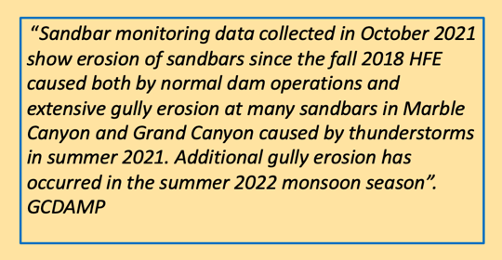
And at times, one RCE benefit negates another as evidenced by the deliberation to conduct a Fall 2022 HFE³⁰. Despite the estimate that the runoff from the Paria from July to Nov 30, 2022 deposited 1,600,000 metric tons of sediment - it was decided against an HFE as it “posed an unacceptable risks to the humpback chub because of the increased risk of distributing smallmouth bass downstream.”
Figure 23 Quote: Sandbar Erosion due Dam Operations

Not with standing all of the foregoing dichotomy, Reclamation’s annual report to Congress lauds the efforts to minimize the damage done to the river’s ecosystem….the reader is left with a sense of having attended a pep rally.

Lastly, GCDAMP is encouraged to consider the state of the RCE prior to the dam’s construction and advocate for modifications and operations that will return it to its original health - to the greatest extent possible. It doesn’t have to be one or the other – the necessary modifications will generate power and benefit the RCE as well as accommodate the extremes of runoff and droughts that climate change will bring about.

Two Actions That Can Be Taken Now

- Stop fluctuating the daily flow and eroding the beaches. The fluctuation subsidizes WAPA’s preferred customers with the lowest electric rates in the nation. Instead, operate the dam with a base flow that can be seasonally adjusted per Law of the River demands.

- Annually conduct an HFE to replicate the historic annual peak inflow of 45,000 cfs - regardless whether or not the Paria and/or Little Colorado River contributed sediment that year. The aforementioned 1.6 million tons of sediment is distributed on the river bed and contributes to the sandbar buildup in the Quarter Master section of the river.

Wrapping Up

The blueprint for adding the necessary modifications already exists. The 1956 CRSP authorized the construction of “appurtenant structures.” An inlet tower and/or a tunnel bypass are appurtenant structures. They can be integrated with power plants to generate electric power. Congress would have to allocate funding, which would be repaid by revenue from the sale of electric power and pay for the operations and maintenance as set forth in the CRSP. The Congressional Research Service Report pointed out that the issue before Congress is to determine what if any modifications to the dam’s water and power facilities are warranted to respond to low storage levels.

The following highlights this paper’s recommended increase in operability of GCD and modifications needed to benefit the RCE:

Access to the ~1.75 million acre feet below the ROW or dead pool.
Transport of sediment downstream
Warmer releases for given times of the year
Allow the restoration of the Glen Canyon
Release storm inflows to prior to spillway releases
Allow for greater historic flooding of the river corridor
Increase hydropower capacity
Insure capability of meeting downstream demands

About the Author
John Vrymoed is a registered Civil and Geotechnical Engineer in California. Currently retired, he oversaw engineering projects as chief of dam design and served in administrative functions as manager with the California Department Water Resources. He is a published author on topics related to earthquake engineering and dam performance, served on a panel of experts for the US Army Corps of Engineers and given presentations at various conferences.

A private boater, he has been down various rivers in the Western US and completed numerous trips down the Colorado River thru the Grand Canyon. He currently serves as President of the Grand Canyon Private Boaters’ Association. He can be contacted at gcpbamail@gmail.com

United States Department of Interior, USBR, Technical Record of Design and Construction, Denver, Colorado, December 1970
Ibid.
Ibid.
Vrymoed, J. “Colorado Historic High Water Within the Grand Canyon”, December 2018, https://shorturl.at/ioJ26
Ibid.
United States Department of Interior, USBR, Technical Record of Design and Construction, Denver, Colorado, December 1970
Bureau of Reclamation, Glen Canyon Dam, Low-Head Hydro Modifications, https://shorturl.at/ptwX5
Milbrandt, A, Heimiller, D., Schwabe, P., 2018, Techno-Economic Renewable Energy Potential on Tribal Lands, NREL/TP- 6A20-70807, https://shorturl.at/cCQ46
Wyatt, J., Kristian, M. The True Land Footprint of Solar Energy, Sept. 2021, Great Plains Institute, https://shorturl.at/cejT6
Greg Schellenberg, C. Richard Donnelly, Charles Holder and Rajib Ahsan, Dealing with Sediment: Effects on Dams and Hydropower Generation, Hydro Review, 2/22/2017
USACE EM 1110-2-2400 2 June 03, Structural Design and Evaluation of Outlet Works, https://shorturl.at/cIJ57
Association of State Dam Safety Officials, Lessons Learned: All dams need an operable means of drawing down the reservoir, https://shorturl.at/giwF0
13 Vernieu, WS; Hueftle, SJ; Gloss, SP, “Water quality in the Lake Powell and the Colorado River”, 2005, USGS Information Services, Denver CO 80225- 0046 USA, https://shorturl.at/nqAHS
Stone, D. et al., “Effects of Disparate Water Temperatures and the Food Bases on the Humpback Chub Growth Rates Within the Little Colorado River, North American Journal of Fisheries Management, March 2020, https://shorturl.at/kwMX6
Evans, J. “Contaminated Sediment and Dam Removals: Problem or Opportunity?” Eos, October 2015, https://shorturl.at/aivwG
Personal Communication, Paul Grams, GCMRC, Sept 2023
Luke Perkins, Gold King Mine Spill, Colorado Encyclopedia, Accessed 9 November 2023 https://rebrand.ly/gyyqlzf
Youtube video, https://www.youtube.com/watch?v=96mpc0UxuZk&t=30s
Appendix A Reclamation Projects Authorization and Adjustment Act of 1992 Title XVIII Section 1801. National Academies of Sciences, National Academies Press.
US Dep’t of Interior, Record of Decision, LTEMP, Final EIS, December 2016, https://shorturl.at/duFV2
US Department of Energy, Argonne National Laboratory, Financial Analysis of Experimental Releases, https://shorturl.at/iALP9
James l. Colorado River Energy Distributors Association, Post 2026 operation EIS comments, August 2023 https://shorturl.at/hvy12
Walton, B., Circle of Blue, June 6, 2022, https://shorturl.at/eitvQ
Stern, C., Lawson, A., “Long-Term and Glen Canyon Dam: Potential Effects on Water Deliveries and Hydropower”, Congressional Research Service, April 2023
Glen Canyon Institute, Hydropower – Key Considerations for FMF Phase III, https://www.glencanyon.org/hydropower/
Reclamation, “Managing Water in the West – Hydropower, July 2005, https://shorturl.at/krswH
Platte River Authority, External Communication, Nov 2023
Glen Canyon Dam Adaptive Management Program, Wiki, A 2022 Fall HFE, https://shorturl.at/acjnH
GCMR FY 2023 Budget Overview webinar June 15, 2022, https://shorturl.at/rNOTV
Boatman’s Quarterly Review, Volume 34, Number 4, Winter 2011 – 2022, A Letter to Mr. Wayne Pullan, Glen Canyon Dam Adaptive Management Program Designee for the Honorable Deb Haaland, Secretary of the Interior: 27 October 202, https://shorturl.at/stuy2
Glen Canyon Dam Long Term Experimental Management Plan, Final EIS, October 2016, https://shorturl.at/bGPQV
Reclamation, Managing Water in the West, Report to Congress on the Operations of Glen Canyon Dam, 2015, https://t.ly/BiYeh

